# Homework: CSS-Presentation

<https://softuni.bg/forum/2288/homework-web-fundamentals-html-css-css-presentation-sept-2014>

<https://answers.yahoo.com/question/index?qid=20130819133148AAKeaYG>

<https://github.com/Filkolev/SoftUni/blob/master/Web%20Fundamentals/Homeworks/Homework-04/02.SoftUniHawaiiVacation/style.css>

<https://github.com/tockata/Web-Fundamentals-HTML-CSS/tree/master/05-CSS-Presentation-Homework>

This document defines homework assignments from the [“Web Fundamentals (HTML & CSS)“ Course @ SoftUni](https://softuni.bg/courses/web-fundamentals/). Please submit as homework a single zip / 7z archive holding the source code of all below described problems.

## The Jaunty Text Field

Create a HTML page like the image below. **100% accuracy is required.** Use **external CSS file** for the styles. Note that you do not have buttons, but text fields.

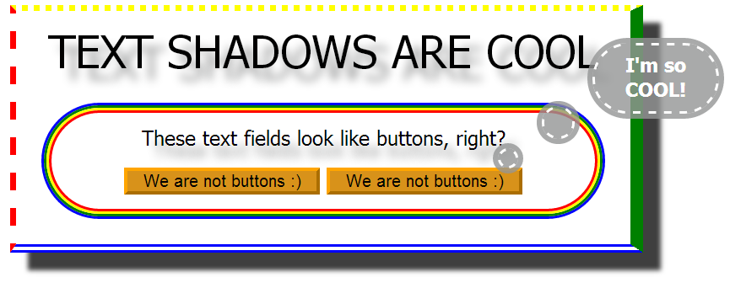

## SoftUni Hawaii Vacation

Create a HTML page like the image below. **100% accuracy is required.** Use **external CSS** file for the styles. You are given PNG files for the background, the figures and the TTF file of the font. Use radial gradient for the sky and the sun.

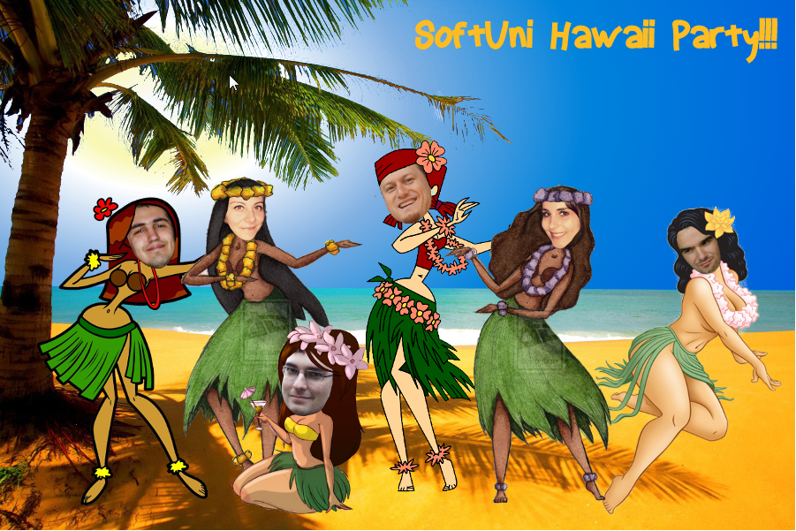

## Styling a HTML Form

Create a HTML page like the image below. **100% accuracy is required.** Use **external CSS** file for the styles. You are given PNG file for the background. Implement effects for active text field.

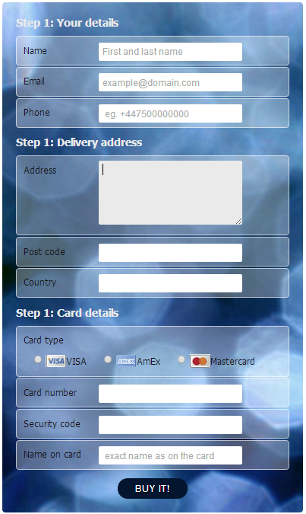

## * Nested <div> Elements

<https://github.com/Jazastry/SoftUni/blob/master/Web%20Fondamentals/CSS-Basics/2-Presentation-Tags/7-Homework-CSS-Presentation/4-Nested-div-Elements/nested-div-elements.html>

Create a HTML page like the image below. Use 60 nested <div> elements.Use **external CSS file** for the styles.

Hint: You may use Emmet (<http://emmet.io>) to simplify your coding effort.

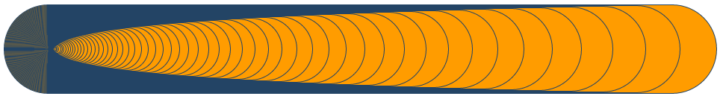

## * Programmer Calculator

<https://thecodeistrueorfalse.wordpress.com/2014/04/27/telerik-css-course-homeworks-presentation-css-%D0%BF%D1%80%D0%B0%D0%B2%D0%B8%D0%BB%D0%B0-%D0%B7%D0%B0-%D0%BF%D1%80%D0%B5%D0%B7%D0%B5%D0%BD%D1%82%D0%B0%D1%86%D0%B8%D1%8F/>

<http://stackoverflow.com/questions/23167637/is-it-possible-to-change-the-color-of-selected-radio-buttons-center-circle>

Create a HTML page that looks like the Windows calculator in Programmer view (see the image below). **100% accuracy is required**. Use **external CSS** file for the styles. Implement hover effect for the buttons. The calculator should not have any functionality.

